PROJECT DEMONSTRATION
ServiceNow-Based Employee Laptop Request Application
Final Phase — Demonstration Guide and Visual Walkthrough

1. Purpose
This section demonstrates the complete flow of the ServiceNow-based employee laptop request application: request submission, duplicate validation, manager approval, status update, notification, and access control.

2. Demonstration Environment
- Platform: ServiceNow development instance.
- Interface: Service Portal / Service Catalog Record Producer.
- Data: custom Laptop Request Form table with user reference fields.
- Validation: Business Rule prevents duplicate requests within the same calendar year.
- Workflow: Flow Designer manager approval and status updates.
- Security: IT Employee and IT Manager roles, groups, and ACLs.

3. End-to-End Workflow
Step | Action | Expected outcome
1 | Employee opens and fills request form | Standardized request details captured
2 | Employee submits request | Record created in Laptop Request Form table
3 | Business Rule checks for duplicate | Second same-year request is blocked
4 | Flow Designer starts approval | Request sent to IT Manager
5 | Manager approves or rejects | Request status is updated
6 | Notification is sent | Employee receives outcome
7 | Roles and ACLs are checked | Access follows configured permissions

4. Demonstration Screenshots / Visual Walkthrough
Important: The following images are illustrative mockups, not screenshots captured from a live ServiceNow instance. Replace them with actual screenshots from your instance if implementation evidence is required.

4.1 Laptop Request Form
Show the Record Producer form and the fields used to submit a laptop request.
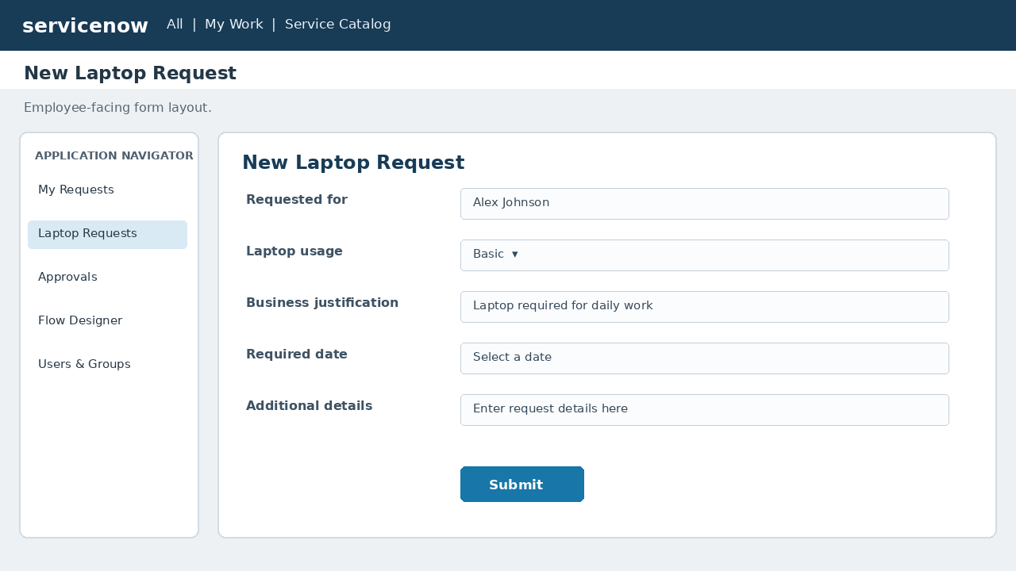
Figure 1. aptop Request Form (illustrative mockup).

4.2 Request Submission
Show the newly created request record and current status.
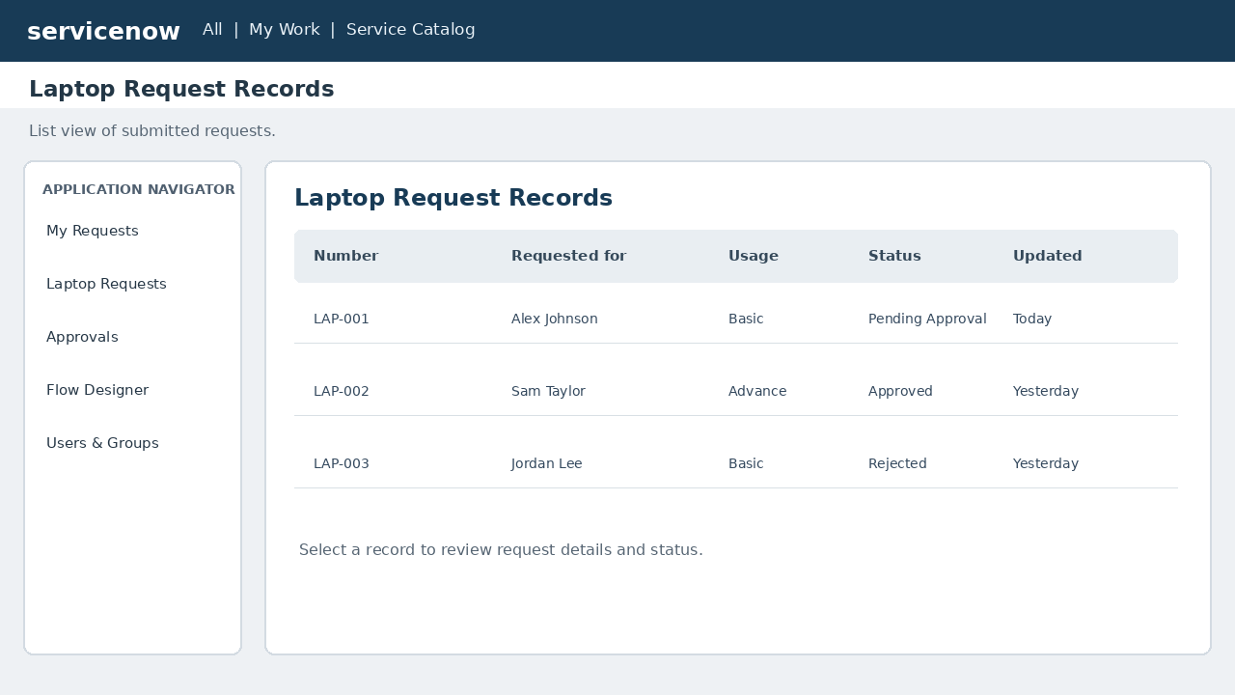
Figure 2. equest Submission (illustrative mockup).

4.3 Duplicate Request Validation
Attempt a second request in the same calendar year and show the Business Rule result.
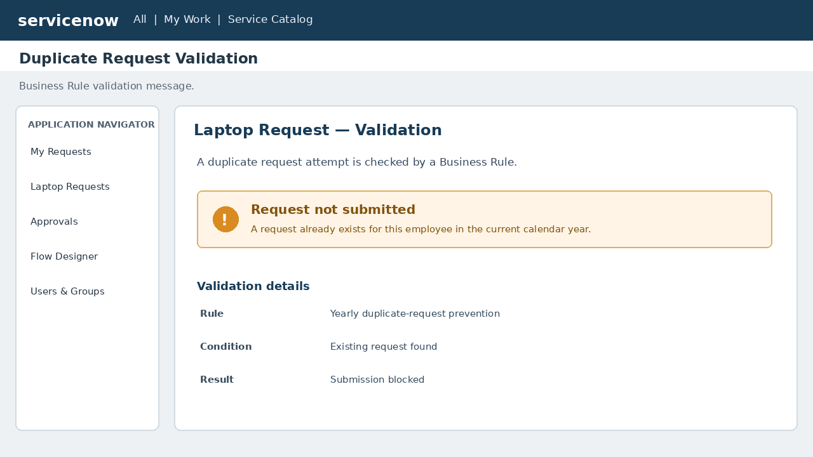
Figure 3. uplicate Request Validation (illustrative mockup).

4.4 Flow Designer Approval
Show the approval trigger, manager approval action, status updates, and notification steps.
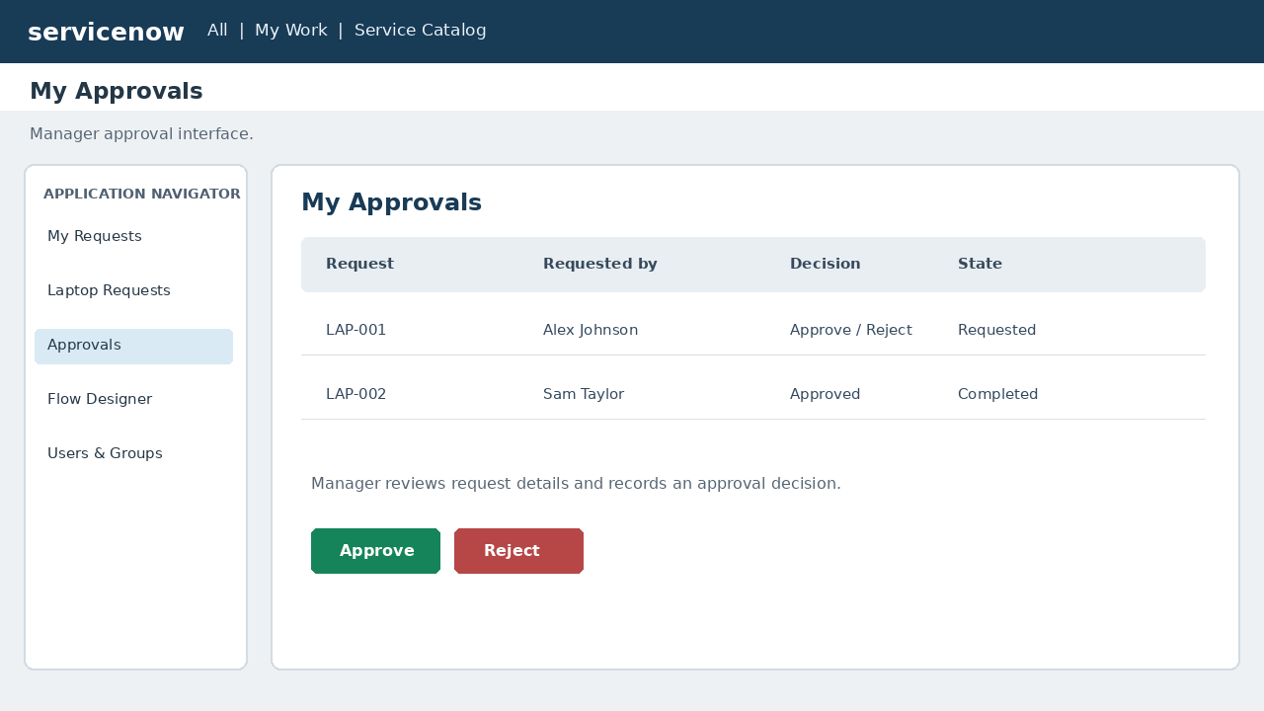
Figure 4. low Designer Approval (illustrative mockup).

4.5 Roles, Groups and ACLs
Show IT Employee and IT Manager permissions and the relevant table-level ACLs.
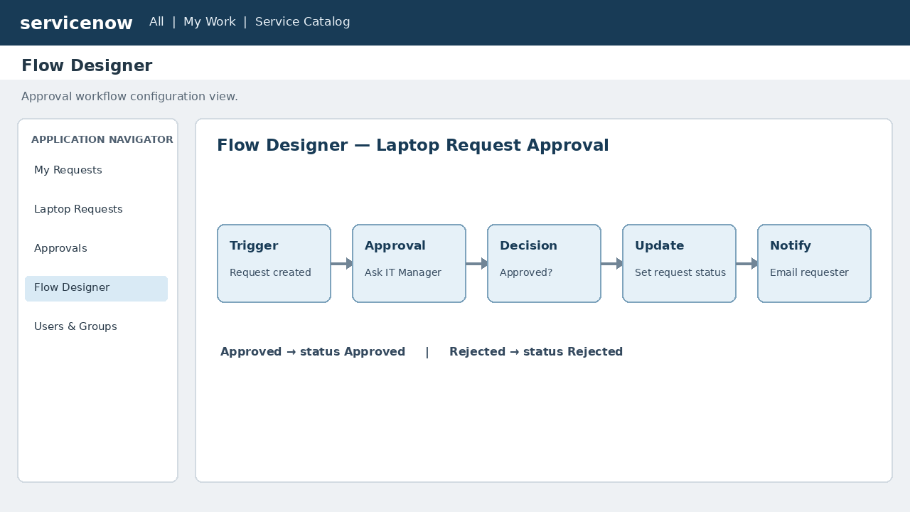
Figure 5. oles, Groups and ACLs (illustrative mockup).

4.6 Functional Test Results
Show the actual outcomes for request creation, editing, duplicate prevention, and manager access.
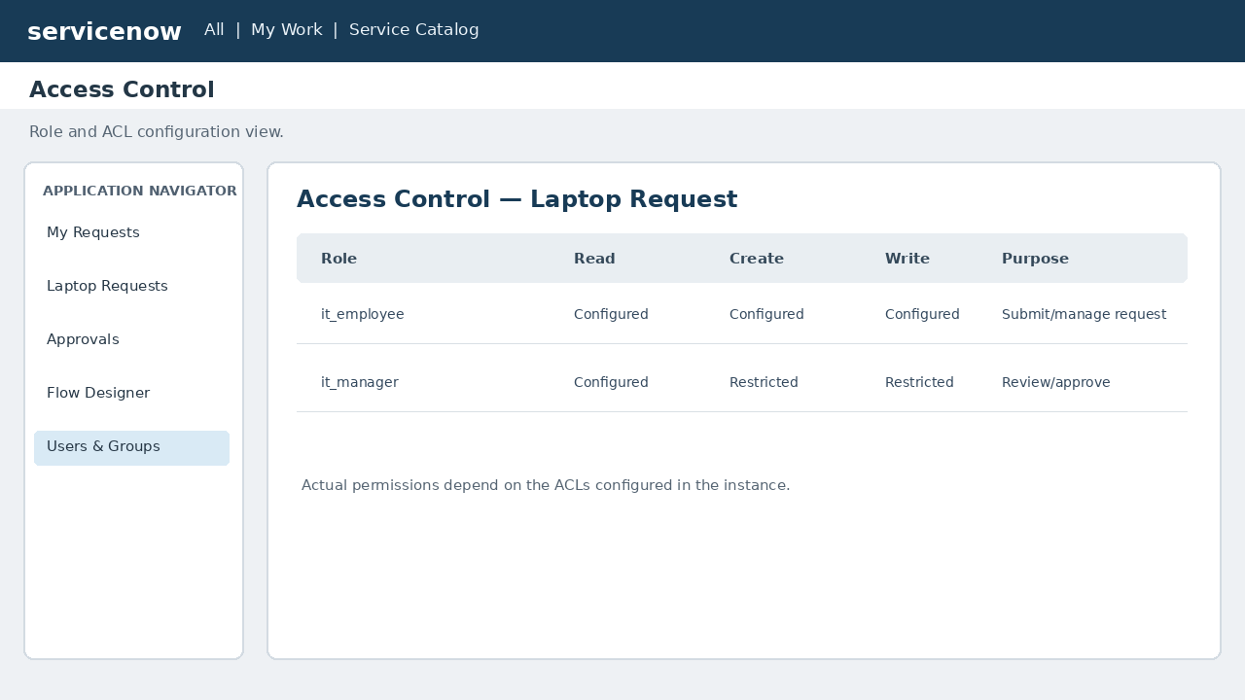
Figure 6. unctional Test Results (illustrative mockup).

5. Live Demonstration Script
- Log in to the ServiceNow development instance using an employee test account.
- Open the Service Catalog / Record Producer and enter laptop request details.
- Submit the request and show the created record and initial status.
- Attempt a second request in the same calendar year and demonstrate duplicate prevention.
- Open Flow Designer and explain the trigger, manager approval, status update, and notification actions.
- Use an IT Manager test account to review and approve or reject the request.
- Show the updated request status and notification to the requester.
- Show roles, groups, and ACL configuration and explain the access restrictions.
- Summarize the functional test scenarios. Do not claim response-time or load-test results unless measured.

6. Expected Demonstration Outcome
The demonstration should show that the application standardizes laptop request submission, prevents duplicate requests within the same calendar year, automates manager approval, updates request status, notifies the employee, and enforces role-based access.

7. Presenter Checklist
- Prepare employee and IT Manager test accounts.
- Confirm the Record Producer and request table are available.
- Prepare an existing request for the duplicate-request test.
- Open the Business Rule and Flow Designer before the presentation.
- Capture actual screenshots and replace illustrative mockups before final submission.
- Use only observed test outcomes; quantitative performance measurements were not supplied in the project documentation.

